LAB EXPERIMENT RECORD
SET 7: Customer Demographics Analysis
Department | AI&DS
Course Code / Course Name | DSA0602 / Data Handling and Visualization
Experiment | Data Visualization using R
Name | DEVAMADA HEMASREE
Register Number | 192524114
Date | 03 OCTOBER 2026
Day | SATURDAY

SET 7: Customer Demographics Analysis
Aim: To visualize customer demographics using a bar chart, pie chart, and table in R, and to build an interactive dashboard using Tableau.
Customer ID | Age | Gender | Income (in $)
1 | 28 | Female | 50,000
2 | 35 | Male | 60,000
3 | 42 | Female | 75,000

PROGRAM 1: Bar Chart (Distribution of Customer Ages)
Aim: To show the distribution of customer ages using a bar chart.
graphics.off()
age <- c(28, 35, 42)

age_group <- cut(age, breaks = c(19, 29, 39, 49),
labels = c("20-29", "30-39", "40-49"))
count <- table(age_group)

barplot(count,
xlab = "Age Group", ylab = "Number of Customers",
main = "Distribution of Customer Ages",
col = "skyblue", ylim = c(0, 2))
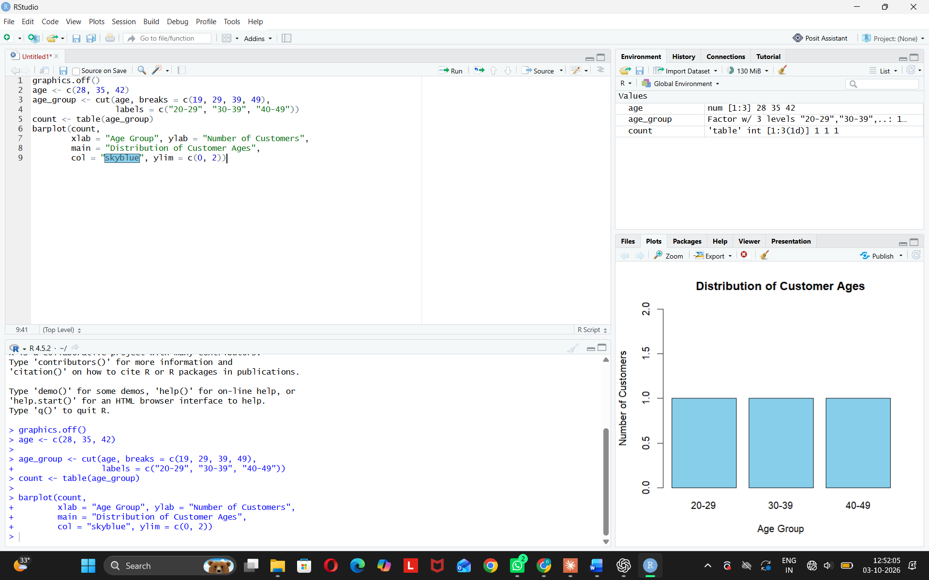
Observation: Customers are spread equally across the three age groups.
PROGRAM 2: Pie Chart (Customers by Gender)
Aim: To show the distribution of customers by gender.
graphics.off()
gender <- c("Female", "Male", "Female")
freq <- as.numeric(table(gender))
names(freq) <- c("Female", "Male")
labels <- paste(names(freq), ":", round(freq / sum(freq) * 100), "%")

pie(freq, labels = labels,
main = "Customers by Gender",
col = c("pink", "lightblue"))
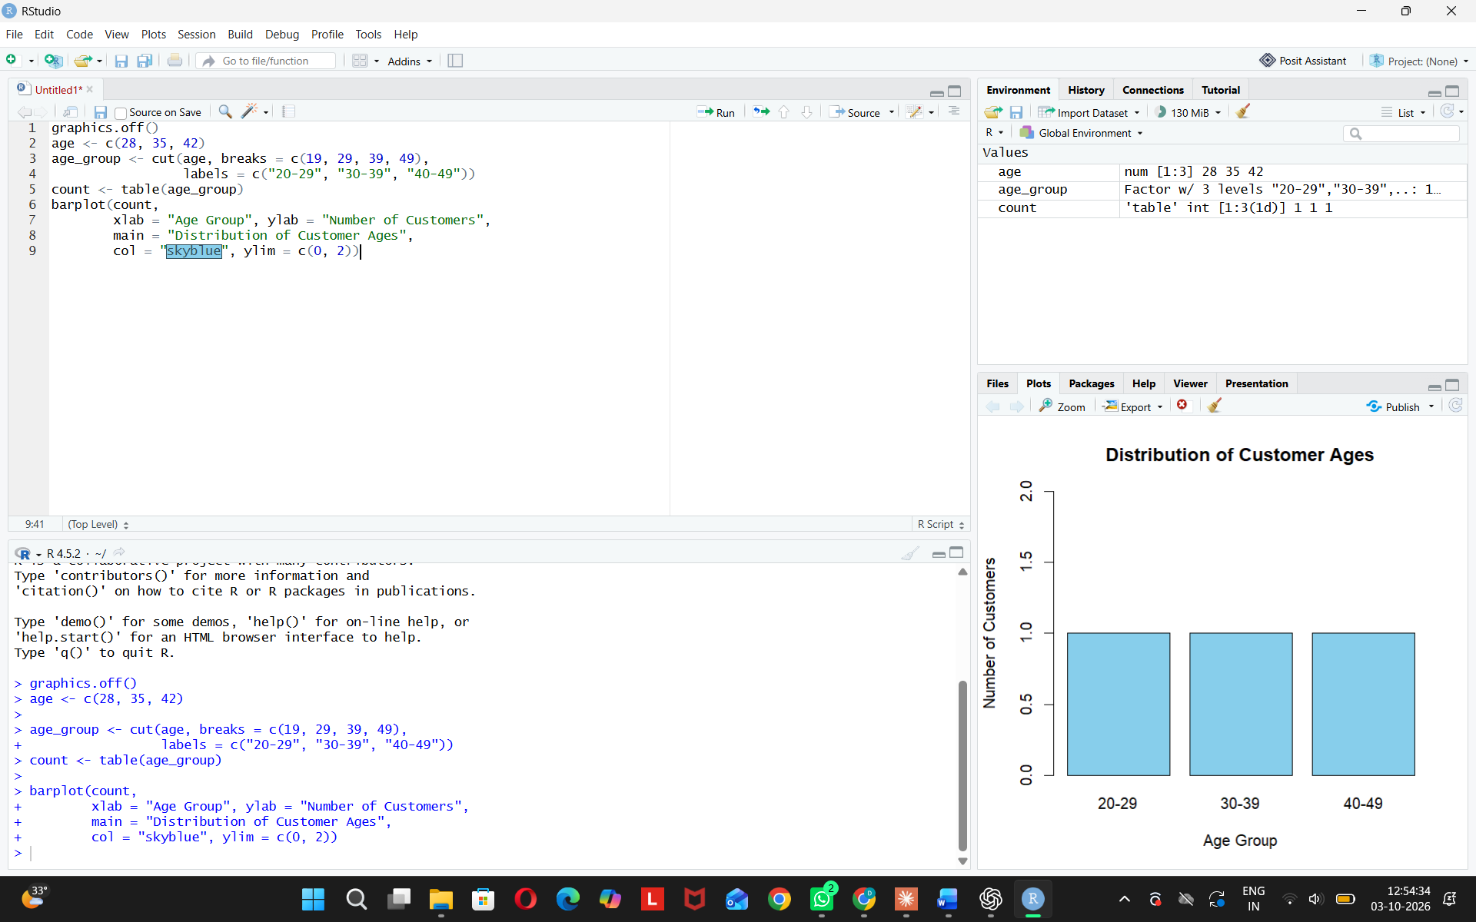
Observation: Female customers are the majority (2 out of 3).
PROGRAM 3: Table (Demographic Information)
Aim: To show the demographic information of each customer in a table.
Customer_ID <- c(1, 2, 3)
Age <- c(28, 35, 42)
Gender <- c("Female", "Male", "Female")
Income <- c(50000, 60000, 75000)

table_data <- data.frame(Customer_ID, Age, Gender, Income)

print(table_data)
View(table_data)
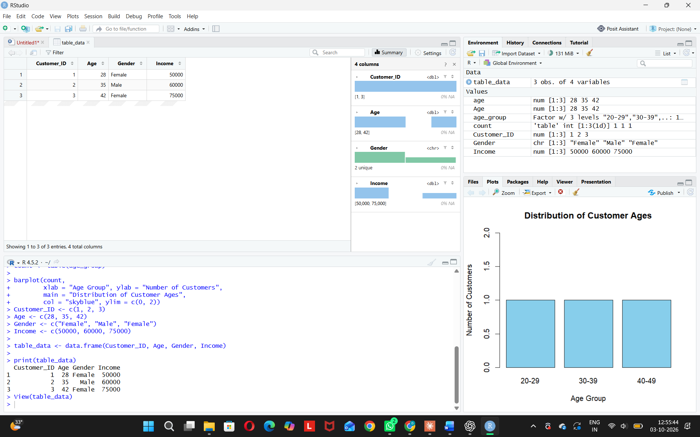
Observation: Income increases with age. The oldest customer (42) has the highest income ($75000).
PROGRAM 4: Tableau Dashboard
Aim: To build an interactive dashboard with the bar chart, pie chart, and table in Tableau.
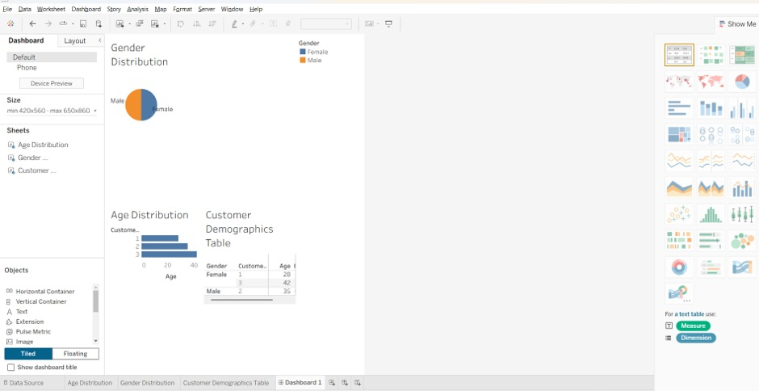
Observation: The user can explore customer demographics interactively.

